**React JS Frontend hosting at S3**

Amazon S3 to host a static website of react JS. On a *static* website, individual web pages include static content. They might also contain client-side scripts.

**Key benefits of using AWS S3 static website hosting**

1. manages everything, so there’s no need for you to worry about underlying software

like the web server or the operating system in general.

2. scales well for temporary high traffic load.

3. It is cheap (in the Frankfurt region, the cost is $0.00043 per 1,000 GET requests).

4. It has great integration with CloudFront CDN for better load performance.

5. It is simple to operate, allowing you to set up your website in a blink of an eye once it is

configured.

6. Free SSL for https from AWS Certificate Manager.

**Total Billing Estimates for hosting static site on S3**

We will use 3 components for Host an React JS Fronted site on S3.

1. AWS S3 Bucket :- Typically, it will cost $1-3/month if you are outside the AWS Free Tier limits. If you are eligible for AWS Free Tier and within these limits, hosting your static website will cost around $0.50/month
2. AWS Route 53 DNS for Domain :- $0.50/month
3. aws cloudfront CDN :- If you created your account in the past 12 months, you are eligible for the AWS Free Tier. With AWS Free Tier, the first 50GB of data transferred out and the first 2,000,000 HTTP/HTTPS requests are free so for this example, your bill for the month would be reduced to $0.00.

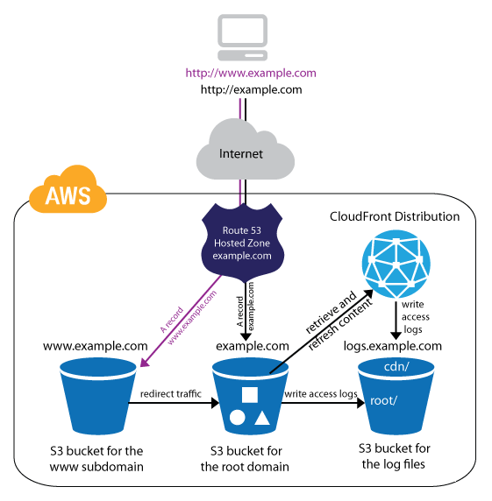

**NodeJS for Backend (EC2)**

We will have to use EC2 for Beckend to deploy NodeJS

**Total Billing Estimates for EC2 (t2.medium Ubuntu 16.04 LTS)**

Configuration :-

RAM : 4GB

CPU : 2 Core

Cost : $35 / Month

**S3 Storage for store Static data data like images**

1. First 50 TB/ month $0.023 / GB.
2. PUT, COPY, POST, or LIST $0.005 / 1,000 requests $0.01 / 1,000 requests
3. GET and all other requests $0.004 / 10,000 requests $0.01 / 10,000 requests

**AWS Lambda**

AWS Lambda lets you run code without provisioning or managing servers. You pay only for the compute time you consume.

With Lambda, you can run code for virtually any type of application or backend service - all with zero administration.

Cost :-

Requests $0.20 per 1M requests

Duration $0.0000166667 for every GB-second

Memory(MB) Price per 100ms

128 $0.0000002083

512 $0.0000008333

1024 $0.0000016667

1536 $0.0000025000

2048 $0.0000033333

3008 $0.0000048958

